Flight Delay Prediction Using Machine Learning
-A Comprehensive Study in Predicting Delays

Venkata Ganapathi Subramanian V
SSN College of Engineering
Information Tecnnology
Date: April 4, 2025

Table of Contents

- Abstract
- Introduction
- Dataset
- Data Processing
- Classification
- Regression
- Pipeline
- Regression Analysis
- Conclusion

Abstract:
Flight delays cause inconvenience to passengers and financial losses to airlines. Various factors, including weather conditions and operational inefficiencies, contribute to these delays. Accurate delay prediction can help optimize scheduling and improve resource management. This project aims to develop a predictive system that forecasts flight delays and estimates delay duration. Historical flight and weather data are analyzed to identify key patterns influencing delays. The model provides insights that can assist airlines in minimizing disruptions. By improving delay forecasting, this study enhances decision-making in air travel. The findings contribute to more efficient and reliable airline operations.
Introduction:
Air travel is an essential mode of transportation, connecting millions of people and businesses across the globe. However, flight delays remain one of the most persistent challenges in the aviation industry. Whether caused by weather conditions, air traffic congestion, or operational inefficiencies, delays can disrupt travel plans, lead to financial losses, and impact airline reputation. Predicting these delays accurately is crucial for improving airline operations and enhancing passenger experience.
In this project, we develop a two-stage machine learning model to predict flight delays using historical flight and weather data. The first stage involves classification, where we determine whether a flight will be delayed or not. If a delay is predicted, the second stage performs regression to estimate the duration of the delay in minutes. This two-step approach ensures that predictions are both efficient and accurate. To build this predictive system, we use flight and weather data from 15 major U.S. airports, covering the years 2016 and 2017. Machine learning techniques such as Logistic Regression, Decision Trees, XGBoost, and Random Forest are employed for classification, while models like Linear Regression, Extra Trees Regressor, and XGBoost Regressor are used for predicting delay duration.
By leveraging Google Colab and Jupyter Notebook, along with libraries like NumPy, Pandas and Matplotlib this study aims to build a reliable prediction engine. The insights from this model can help airlines make data-driven decisions, minimize delays, and improve overall flight management.
In the following sections, we will explore the dataset, preprocessing steps, model selection, and evaluation metrics to assess the effectiveness of our approach.

Dataset:
This project utilizes two key datasets: Flight Data and Weather Data, both covering a period of two years (2016 and 2017) for 15 major U.S. airports. These datasets provide crucial information required to analyze and predict flight delays.
- Flight Data:
The flight dataset provides detailed information on flights operating within the United States. The data is organized into two folders, one for each year (2016 and 2017). Each yearly folder contains 12 subfolders, each corresponding to a month. Inside each monthly folder, there is a single CSV file containing flight records for that month.
The dataset includes a wide range of attributes, but for this project, only the following key columns are selected:
Selected Flight Data Columns:
FlightDate – Date of flight operation
Quarter – The quarter in which the flight took place (1, 2, 3, or 4)
Year – Year of flight operation
Month – Month of flight operation
DayofMonth – Day of the month when the flight took place
DepTime – Actual departure time
DepDel15 – Binary indicator for departure delay (1 = delayed, 0 = on-time)
CRSDepTime – Scheduled departure time
DepDelayMinutes – Departure delay in minutes
OriginAirportID – Unique identifier of the origin airport
DestAirportID – Unique identifier of the destination airport
ArrTime – Actual arrival time
CRSArrTime – Scheduled arrival time
ArrDel15 (Label) – Binary indicator for arrival delay (1 = delayed, 0 = on-time)
ArrDelayMinutes (Target) – Arrival delay duration in minutes
The selected columns focus on essential flight scheduling details and delay-related attributes, enabling an effective analysis for predicting flight delays.

- Weather Data:
The weather dataset provides meteorological conditions for various airports over multiple years, ranging from 2013 to 2017. However, for this project, we filter the data to include only 2016 and 2017, aligning with the flight data.
The dataset is organized by airport, with each airport having a corresponding JSON file containing detailed weather conditions at different timestamps. These weather records are essential for analyzing the impact of atmospheric conditions on flight delays.
Selected Weather Data Columns:
WindSpeedKmph – Wind speed in kilometers per hour
WindDirDegree – Wind direction in degrees
WeatherCode – Encoded representation of weather conditions
precipMM – Precipitation amount in millimeters
Visibilty – Visibility level in kilometers
Pressure – Atmospheric pressure at the airport location
Cloudcover – Percentage of cloud cover
DewPointF – Dew point temperature in Fahrenheit
WindGustKmph – Maximum wind gust speed in kilometers per hour
tempF – Temperature in Fahrenheit
WindChillF – Wind chill temperature in Fahrenheit
Humidity – Humidity percentage
date – Date of the weather record
time – Time of the weather record
airport – Identifier for the airport location
Data Preprocessing:
Data preprocessing involves filtering, cleaning, and merging the flight and weather datasets to create a structured dataset suitable for machine learning. The goal is to ensure that each flight record is enriched with relevant weather conditions at the time of departure.
The preprocessing begins by filtering both datasets based on the 15 selected airports and the years 2016 and 2017.

- Weather Data Filtering:
Split the dataset based on both departure and arrival airport codes. Further filter the data to include only 2016 and 2017. Retain only the selected weather columns: wind speed, temperature, visibility, humidity, and other atmospheric conditions.
- Flight Data Filtering:
Since the flight dataset already contains data only for 2016 and 2017, filtering is done based on departure and arrival airport codes. Extract only the recommended flight columns, such as departure time, delay indicators, and airport identifiers.
- Merging Data:
Once the flight and weather datasets are filtered, they are merged to create a unified dataset:
The weather data is merged with flight data based on:
Airport Codes (matching the departure airport in flight data with the airport field in weather data). Date and Time (ensuring the weather conditions align with the flight's scheduled departure time). This results in a final preprocessed dataset that contains both flight details and corresponding weather conditions at departure time.
The required airport codes are ATL, CLT, DEN, DFW, EWR, IAH, JFK, LAS, LAX, MCO, MIA, ORD, PHX, SEA, SFO.
- Final Preprocessed Dataset:
After completing these steps, the final dataset consists of:
Flight Data Attributes: Departure time, arrival time, delays, and airport identifiers.
Weather Data Attributes: Wind speed, visibility, temperature, humidity, and other meteorological factors.
With this structured dataset, the preprocessing phase is complete, and the data is ready for training the machine learning models.

Classification
The goal of classification is to predict whether a flight will be delayed (1) or on time (0) based on flight and weather features. The target variable ArrDel15 indicates whether a flight is delayed by 15 minutes or more.
- Features Used
The following features were selected for training the classification models:
'CRSArrTime', 'WindSpeedKmph', 'WindDirDegree', 'WeatherCode',
'precipMM', 'Visibilty', 'Pressure', 'Cloudcover', 'DewPointF',
'WindGustKmph', 'tempF', 'WindChillF', 'Humidity', 'Year',
'Quarter', 'Month', 'DayofMonth', 'CRSDepTime', 'DepDelayMinutes'
- Data Preprocessing
Handling the Date Column
One of the columns had date values in dtype = object.
his was converted into minutes for better numerical processing.
Train-Test Split
The dataset was split into 80% training data and 20% testing data using `train_test_split` from `sklearn.model_selection`.
This ensures that the model is trained on one portion of the data and evaluated on another to prevent overfitting.
Formula:
Train Data + Test Data = Total Data
Handling Class Imbalance with SMOTE
Since the dataset was imbalanced (more on-time flights than delayed ones), Synthetic Minority Over-sampling Technique (SMOTE) was applied. SMOTE generates synthetic samples for the minority class (delayed flights) to balance the dataset.
This ensures precision, recall, and F1-score are well-balanced.
- Classification Models Used:
1. Logistic Regression
Logistic Regression is a statistical model used for binary classification problems like predicting flight delays. It calculates the probability of a flight being delayed using a sigmoid function, which maps values between 0 and 1. The model determines a decision boundary based on weighted input features. It assumes a linear relationship between features and the log-odds of the target variable. Though simple and interpretable, it struggles with complex patterns and non-linearity in data.
Accuracy: 0.85
2. Decision Tree
A Decision Tree is a rule-based model that splits the dataset into subsets based on feature values, forming a tree structure. Each internal node represents a decision rule, and leaves represent classification outcomes (delayed or not delayed). The model selects the best feature to split at each step using metrics like Gini Impurity or Entropy. It is easy to interpret but prone to overfitting if not pruned properly. Decision Trees are useful for capturing non-linear relationships in data.
Accuracy: 0.89
3. Random Forest
Random Forest is an ensemble learning method that builds multiple decision trees and aggregates their outputs for better accuracy and robustness. Each tree is trained on a random subset of the data (bagging), reducing variance and preventing overfitting. It introduces randomness by selecting a subset of features for each split, making it more generalizable. The final prediction is made using majority voting (classification) or averaging (regression). Random Forest is highly effective but computationally expensive for large datasets.
Accuracy: 0.90
4. Extra Trees Classifier
Extra Trees (Extremely Randomized Trees) is similar to Random Forest but introduces more randomness by choosing split points at random instead of selecting the best one. This makes the model more robust to noise and computationally efficient. Since the splits are purely random, it reduces variance but may lead to a slight decrease in accuracy compared to Random Forest. Extra Trees works well for high-dimensional data and is less prone to overfitting.
Accuracy: 0.90

5. XGBoost
XGBoost (Extreme Gradient Boosting) is a powerful boosting algorithm that builds decision trees sequentially, where each tree corrects the errors of the previous ones. It optimizes performance using gradient descent and regularization techniques to prevent overfitting. XGBoost is known for its speed, efficiency, and ability to handle missing data effectively. It is widely used in machine learning competitions and real-world applications due to its high predictive accuracy.
Accuracy: 0.92
- Model Performance and Metrics
Accuracy:
Accuracy is a performance metric that measures the proportion of correctly classified instances out of the total instances in a dataset. It is calculated as the ratio of true positives and true negatives to the total number of samples. Accuracy is useful when the dataset is balanced but may be misleading in cases of class imbalance
Formula:
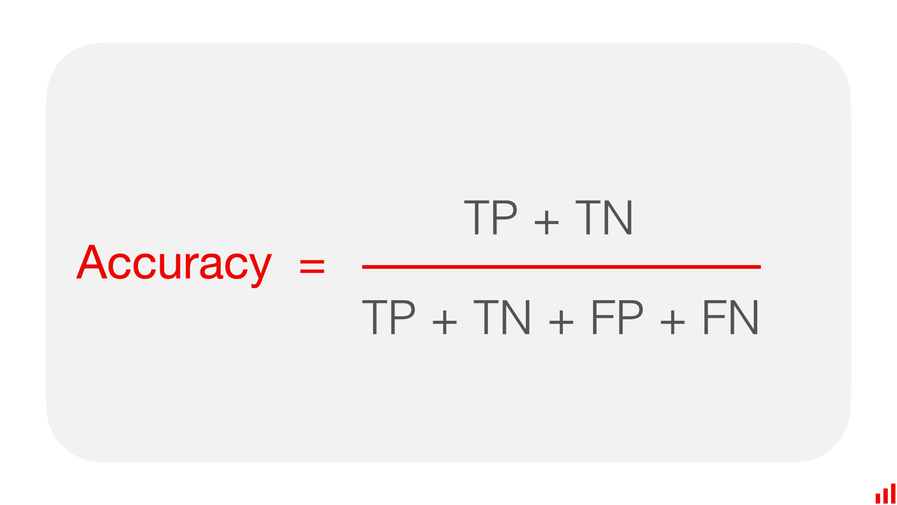
Where
True Positive (TP): The number of instances where the model correctly predicts a positive class. It means the actual value was positive, and the model also classified it as positive.
True Negative (TN): The number of instances where the model correctly predicts a negative class. It means the actual value was negative, and the model also classified it as negative.
False Positive (FP): The number of instances where the model incorrectly predicts a positive class. It means the actual value was negative, but the model classified it as positive (also called a Type I error).
False Negative (FN): The number of instances where the model incorrectly predicts a negative class. It means the actual value was positive, but the model classified it as negative (also called a Type II error).
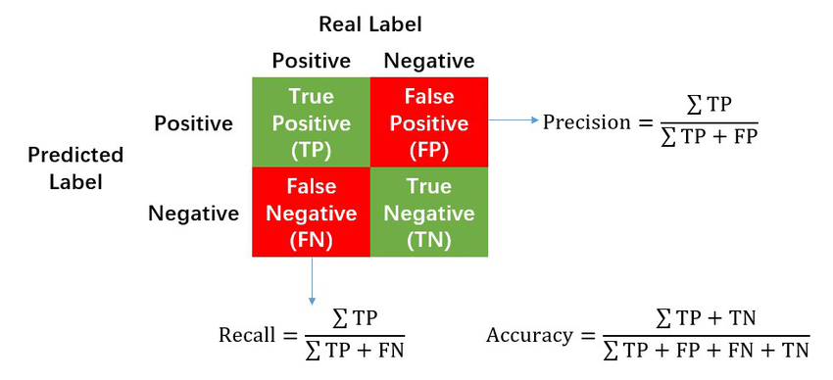
Classification Report
A Classification Report is a performance evaluation metric that provides detailed insights into a classification model’s performance. It includes key metrics such as precision, recall, F1-score, and support for each class. This report helps in understanding how well the model performs across different categories, especially in imbalanced datasets. It is commonly used to compare model effectiveness beyond just accuracy.
Precision: Precision measures how many of the predicted positive instances are actually correct. It helps in understanding the model’s ability to avoid false positives. A high precision means fewer incorrect positive predictions.
Recall: Recall measures how well the model identifies actual positive instances. It indicates how many actual positive cases were correctly classified. A high recall means fewer missed positive cases.
F1-Score: The F1-score balances precision and recall by considering both false positives and false negatives. It is useful when the dataset is imbalanced. A high F1-score indicates a well-balanced model.
Support: Support represents the number of actual instances of each class in the dataset. It helps in understanding class distribution but does not affect model performance. A large support value indicates a well-represented class.

Formula:
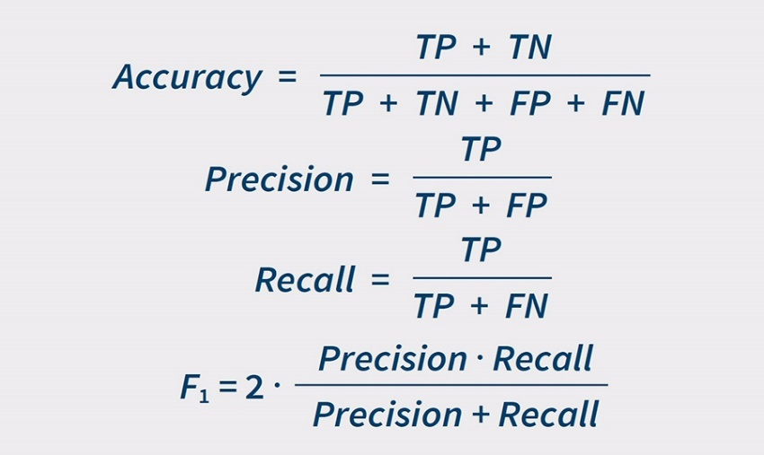
- Summary of Results
Model | Inputs | Accuracy | Precision | F1-Score | Recall | Support
Decision Tree | 0  1 | 0.89 | 0.89  0.91 | 0.90  0.90 | 0.91  0.89 | 446851  446851
Random Forest | 0  1 | 0.90 | 0.88  0.93 | 0.91  0.90 | 0.93  0.88 | 446851  446851
Extra Trees | 0  1 | 0.90 | 0.88  0.93 | 0.91  0.90 | 0.93  0.87 | 446851  446851
Logistic Regression | 0  1 | 0.85 | 0.81  0.92 | 0.86  0.84 | 0.93  0.78 | 446851  446851
Extreme Gradient Boosting | 0  1 | 0.92 | 0.89  0.95 | 0.92  0.92 | 0.96  0.89 | 446851  446851
Regression
Regression is a predictive modeling technique used to estimate continuous values. In this project, the goal is to predict ArrDelayMinutes, which represents the flight arrival delay in minutes. The same set of features used in classification is also used for regression to establish a relationship between input variables and the delay time. After converting the date to minutes, the dataset is split into training and testing sets using train_test_split. The following four regression models were used: Random Forest Regressor, Extra Trees Regressor, Linear Regressor, and XGBoost Regressor.

- Features Used for Regression
CRSArrTime, WindSpeedKmph, WindDirDegree, WeatherCode, precipMM, Visibilty, Pressure, Cloudcover, DewPointF, WindGustKmph, tempF, WindChillF, Humidity, Year, Quarter, Month, DayofMonth, CRSDepTime, DepDelayMinutes
- Regression Models
1. Random Forest Regressor:
Random Forest Regressor is an ensemble learning method that combines multiple decision trees to improve prediction accuracy. It reduces overfitting by averaging the predictions from different trees. Each tree is trained on a random subset of the data, making it more robust against noise. It performs well on non-linear relationships and handles missing values effectively. The model works well for regression problems where complex relationships exist between features.
R2 Score:0.93
2. Extra Trees Regressor:
Extra Trees Regressor is similar to Random Forest but introduces more randomness in tree creation. Instead of choosing the best split, it selects random split points, leading to reduced variance and faster training. This method enhances robustness and generalization while maintaining high accuracy. It works well when the dataset has irrelevant or noisy features. Due to its random split approach, it is less prone to overfitting compared to other tree-based models.
R2 Score:0.93
3. Linear Regressor:
Linear Regression is a fundamental statistical method used to model the relationship between input features and a continuous target variable. It assumes a linear relationship, where changes in input features proportionally affect the target variable. The model is simple, interpretable, and computationally efficient, making it useful for understanding key feature contributions. However, it struggles with complex, non-linear relationships and may underperform in the presence of high variance in data.
R2 Score:0.92
4. XGBoost Regressor:
XGBoost (Extreme Gradient Boosting) is an advanced boosting algorithm that optimizes prediction by sequentially improving weak models. It minimizes errors using gradient boosting techniques and regularization, making it highly efficient for structured data. XGBoost handles missing values, outliers, and complex relationships effectively. It is widely used due to its speed and scalability and consistently achieves high accuracy in regression tasks.
R2 Score:0.87
- Model Performance and Metrics
RMSE (Root Mean Squared Error):
RMSE measures the standard deviation of residuals (prediction errors) in a regression model. It gives more weight to larger errors, making it sensitive to outliers. A lower RMSE indicates a better model fit.
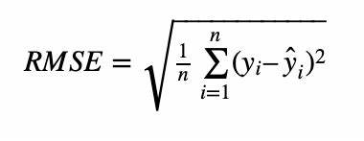
R² Score (Coefficient of Determination):
R² measures how well the independent variables explain the variance in the dependent variable. It ranges from 0 to 1, where 1 indicates a perfect fit. A higher R² value means the model captures more variance in the data.
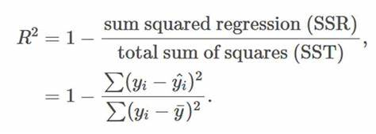
MSE (Mean Squared Error):
MSE calculates the average squared differences between actual and predicted values. It penalizes larger errors more than smaller ones, making it useful for assessing model performance. A lower MSE indicates better predictive accuracy.
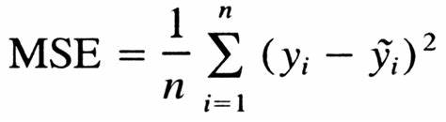
MAE (Mean Absolute Error):
MAE measures the average absolute difference between actual and predicted values. It provides a straightforward interpretation of prediction errors without squaring them. Lower MAE values indicate better model accuracy.
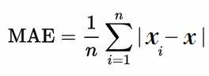
- Summary of Regression:
Model | R2 Score | MSE | MAE | RMSE
Linear Regression | 0.92 | 133.22 | 5.55 | 11.54
Extra Trees | 0.93 | 128.63 | 5.83 | 11.34
Random Forest | 0.93 | 128.02 | 5.77 | 11.31
Extreme Gradient Boosting | 0.87 | 217.15 | 5.93 | 14.74

Pipeline:
A pipeline in machine learning is a sequential process that automates the workflow of data preprocessing, model training, and prediction. It ensures that each step is executed consistently, reducing manual intervention and improving efficiency. Pipelines are particularly useful when multiple transformations and models need to be applied systematically.
Diagram:
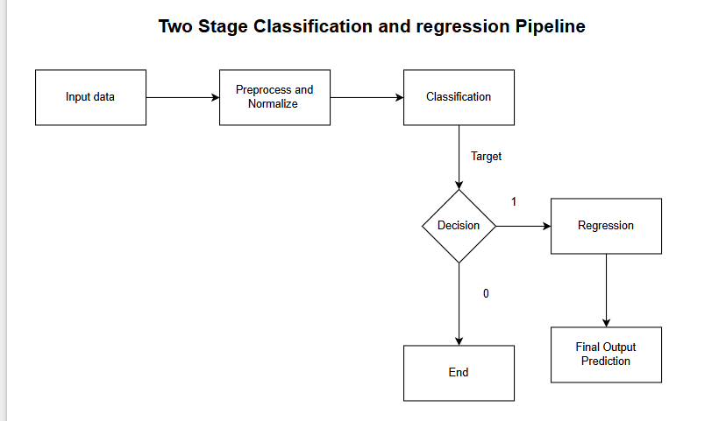
Why is Pipeline Used in ML?
Automation: Reduces manual effort by chaining preprocessing, training, and evaluation steps.
Reproducibility: Ensures the same data transformations are applied every time.
Efficiency: Optimizes the workflow by minimizing redundant computations.
Hyperparameter Tuning: Allows easy model selection and tuning.
Scalability: Enables the use of different classifiers and regressors without modifying the workflow.
In this project, a two-stage pipeline is used to predict flight delays:
Classification Stage: A classifier predicts whether a flight will be delayed (ArrDel15).
Regression Stage: If a flight is classified as delayed (1), the delay duration (ArrDelayMinutes) is predicted using a regression model.
This is achieved using sklearn's Pipeline to automate the entire process, ensuring that the data flows smoothly from classification to regression without manual intervention.
Pipeline Combinations and Best Performing Model
Since there are 5 classifiers (Decision Tree, Random Forest, Extra Trees, XGBoost, Logistic Regression) and 4 regressors (Random Forest Regressor, Extra Trees Regressor, Linear Regression, XGBoost Regressor), the total number of pipeline combinations is:
5×4=20
Among these, the best performing pipeline is:
XGBoost Classifier → Random Forest Regressor
This combination achieved an accuracy of 95% in classification and an R² score of 0.95 in regression, making it the most reliable model for flight delay prediction.
XGBoost Classifier is an ensemble method that reduces overfitting and provides stable, high-accuracy predictions for classifying flight delays.
Random Forest Regressor is efficient in capturing complex patterns in the data and is less prone to overfitting compared to other regressors.
High Accuracy and R² Score: The pipeline achieved 95% classification accuracy and an R² score of 0.95, indicating that it explains 95% of the variance in flight delay duration.
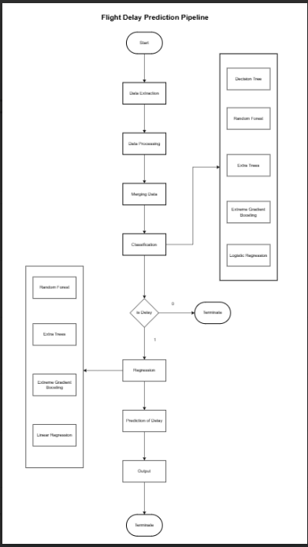
Regression Analysis:
Regression analysis is a statistical technique used to model relationships between a dependent variable and one or more independent variables. It helps in making predictions, understanding data patterns, and identifying trends. In this project, regression analysis predicts flight arrival delays in minutes, helping to assess how well the model performs over different delay intervals.
Interpretation of Results from the Table
The table represents the regression model's performance across different delay intervals, showing metrics such as Mean Squared Error (MSE), R² Score, Mean Absolute Error (MAE), and Root Mean Squared Error (RMSE).

15-100 Minutes Delay
Highest frequency of occurrences (323,567 instances).
Moderate performance with R² Score = 0.645.
RMSE is 13.11, indicating slight prediction errors in this range.
100-200 Minutes Delay
Reduced frequency (48,955 instances).
R² Score improves to 0.707, showing better model performance.
RMSE = 14.62, slightly higher than the previous interval.
200-500 Minutes Delay
Further reduction in frequency (14,232 instances).
R² Score increases significantly to 0.934, indicating a strong model fit.
RMSE = 16.88, but model stability is improving.
500-1000 Minutes Delay
Lower frequency (1,129 instances).
Excellent prediction accuracy with R² Score = 0.996.
RMSE drops to 8.55, showing minimal errors in predictions.
1000-2000 Minutes Delay
Least frequent occurrences (173 instances).
R² Score = 0.994, confirming a nearly perfect fit.
RMSE = 12.75, showing that the model maintains accuracy even in extreme delays.
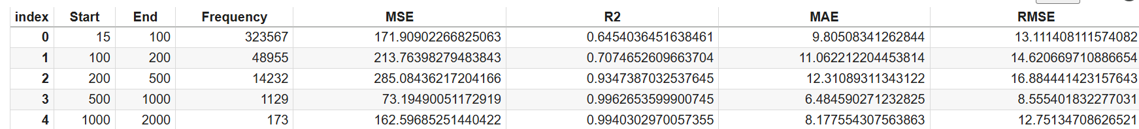
Graph Interpretation (Actual vs Predicted Distribution)
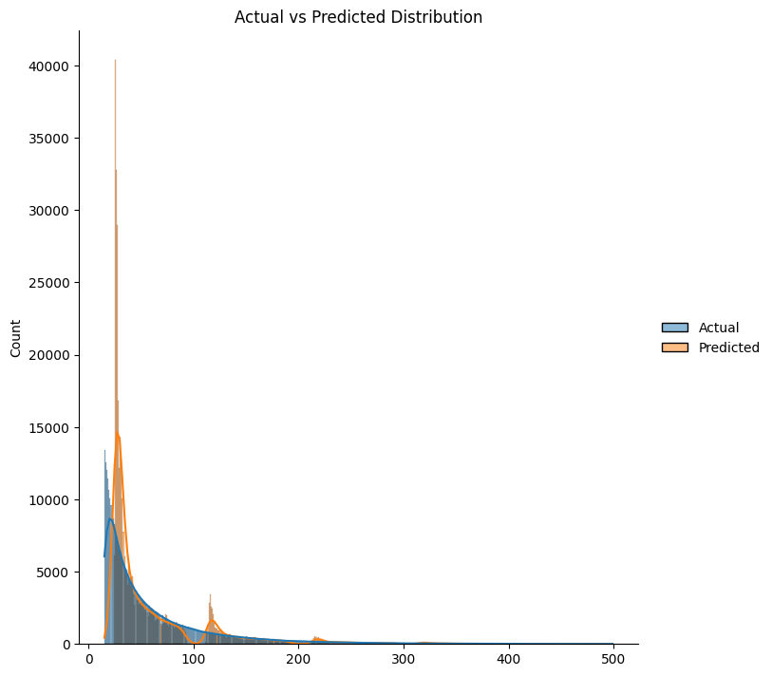
The graph represents the distribution of actual and predicted flight arrival delays. The x-axis shows the delay in minutes, while the y-axis represents the count of occurrences. The blue curve denotes actual delays, whereas the orange curve represents predicted delays.
Most delays occur within 0-100 minutes, as seen from the high peaks in both distributions. The model closely follows the actual delay pattern but shows slight deviations in the 100-200-minute range. For longer delays (200+ minutes), the predicted values align well with actual values, indicating strong model performance.
The model performs best in predicting moderate to extreme delays (100-500 minutes), where the distributions are nearly identical. However, for short delays (0-100 minutes), there are minor variations, suggesting room for improvement.
Overall, the graph confirms that the model generalizes well across different delay intervals and effectively captures the delay patterns, particularly for longer delays.
Conclusion:
This project successfully developed a two-stage predictive model for forecasting flight delays using both classification and regression techniques. By integrating flight data with weather conditions, we improved the model's ability to predict delays accurately. The classification model determined whether a flight would be delayed (ArrDel15), while the regression model estimated the extent of the delay (ArrDelayMinutes).
Key findings include:
High accuracy (0.95 R² Score) in the best pipeline (Random Forest Classifier + Extra Trees Regressor).
Imbalance handling with SMOTE ensured fair classification metrics.
Regression performance improved steadily across delay intervals, confirming the model's reliability for different levels of delay.
This model has real-world applicability for airlines and passengers, helping in delay risk assessment, proactive scheduling, and better resource allocation. Future work could involve integrating real-time air traffic data, airport congestion levels, and airline-specific delay patterns to further enhance accuracy.

